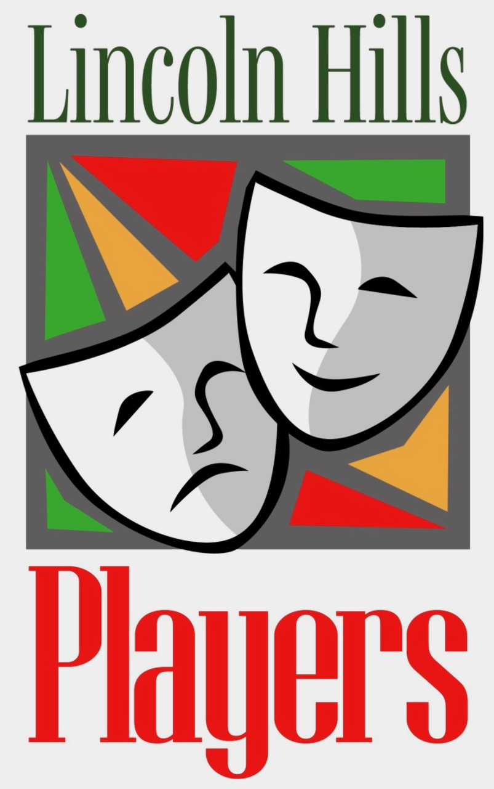
LINCOLN HILLS PLAYERS
Meeting agenda, Monday June 9, 2025

Steering Committee Support Leaders

President: Jane Patton Historian: Linda Wilds-Beltz
Vice President: Richard Fitzmaurice Webmaster: Tom Quallick
Treasurer: Rudy Schneider Publicity: Doug Brown
Secretary: Cindy Griswold Sunshine: Jeri Chase Ferris
Membership: Mary Whittaker Play Reading Committee: Julie Africa (Chair),
Past President: Doug Brown Readers Theater Coordinator: Alan Lowe

- Welcome & Introductions: ( Players leaders; new members, guests) & announcements
- Quorum report (Mary Whittaker)
- Minutes of May 2025 meeting (Cindy Griswold)
- Treasurer’s Report (Rudy Schneider)
- “And Then There Were None” (Mary Ellen Vogt)
- August 2-3 Festival of Short Plays-- cast & details (Cathy Shanley)
- October Readers Theatre audition & show info (Paul Gardner)
- November show: “Moon Over Buffalo” --announcements (Julie Africa)
- Logo T shirt --next steps being discussed
- Late Summer party-- under consideration.
- Members’ Open Forum (comments, suggestions, announcements, questions)
- Closing Fun
  - Birthdays in June
  - Raffle
- Adjourn

