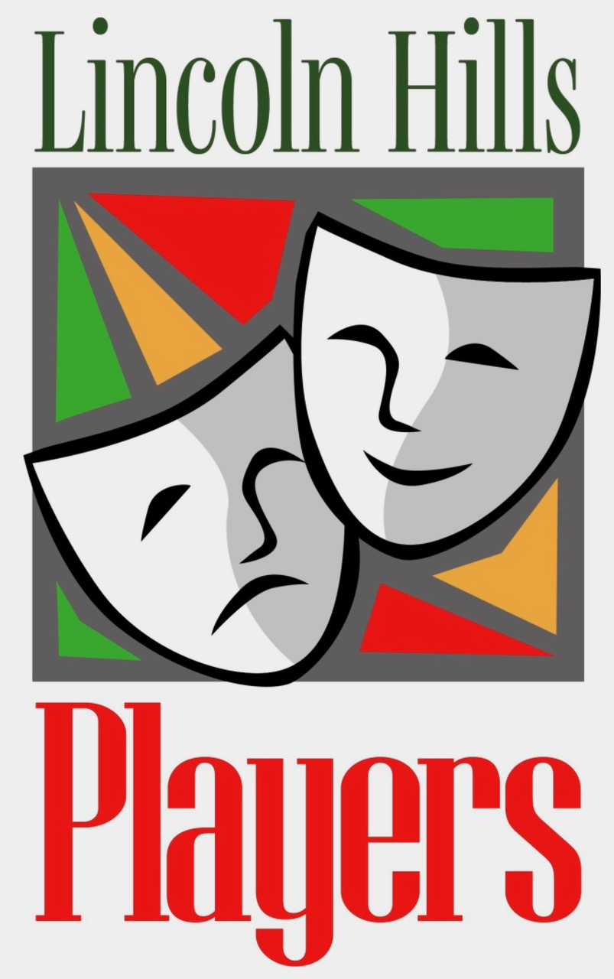
LINCOLN HILLS PLAYERS
Meeting agenda, Monday November 10, 2025 4:00

Steering Committee Support Leaders

President: Jane Patton Historian: Linda Wilds-Beltz
Vice President: Richard Fitzmaurice Webmaster: Tom Quallick
Treasurer: Rudy Schneider Publicity: Doug Brown
Secretary: Cindy Griswold Sunshine: Jeri Chase Ferris
Membership: Mary Whittaker Play Reading Committee: Julie Africa (Chair),
Past President: Doug Brown Readers Theater Coordinator: Alan Lowe

- Introductions: Players leaders; new members; guests; announcements;
Logo shirts Premier Graph X
- Quorum report (Mary)
- Minutes Oct. 2025 (Cindy)
- Treasurer’s Report (Rudy)
- Governing Docs voting
- Moon Over Buffalo debriefing (Julie)
- Feb short Play History of Dating (Cathy S)
- Recruiting for sound effects (Cat Bain)
- Holiday Party Dec 3 –Pay $20.
- Members’ Open Forum
- Closing Fun: Birthdays; Raffle

