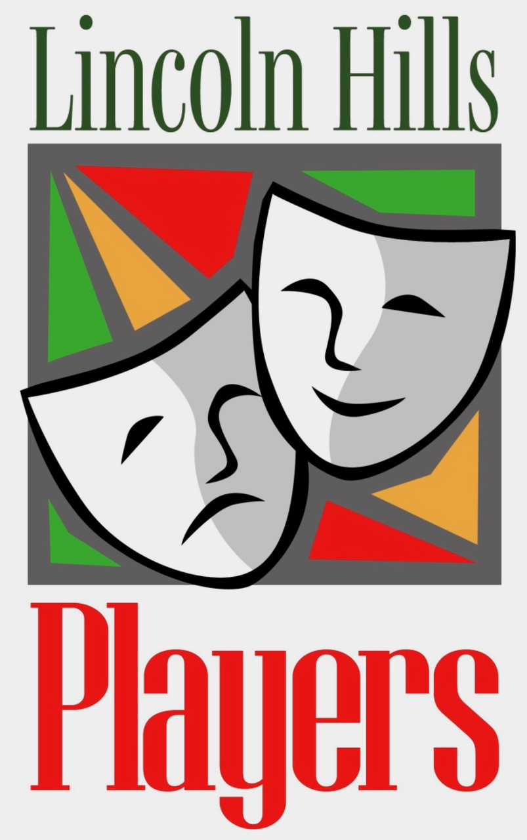
LINCOLN HILLS PLAYERS
Meeting Agenda, Monday April 13, 2026 4:00 PH

Steering Committee Support Leaders

President: Jane Patton Historian: Linda Wilds-Beltz
Vice President: Richard Fitzmaurice Webmaster: Tom Quallick
Treasurer: Rudy Schneider Publicity: Sue Anderson Villarreal
Secretary: Cindy Griswold Sunshine: Jeri Chase Ferris
Membership: Mary Whittaker Play Review Committee: Julie Africa (Chair)
Past President: Doug Brown Tech Director: Jim Moon
Social Coordinator: Karen Pinomaki

- Welcome & Introductions: ( Players leaders; new members, guests) & announcements
Logo shirts Premier Graph X
- Quorum report (Mary Whittaker).
- Approve Minutes of March meeting (Cindy Griswold)
- Treasurer’s Report (Rudy Schneider)
- Update: “It Happened on Route 66” (Sue Villarreal & Richard Fitzmaurice)
- Update: August Short Plays (Karen Pinomaki & MaryEllen Vogt & Chris McCormick)
- Upcoming Players social activities (Karen Pinomaki)
- What is PAC (Doug Brown)
- Members’ Open Forum (comments, suggestions, announcements, questions)
- Closing Fun
  - Birthdays in April
  - Raffle
- Adjourn

